**Supulu Enterprise Project Report**

**Introduction:**

This project involves creating an interactive Excel dashboard to analyze business data and derive actionable insights. The dashboard showcases key metrics such as total revenue by city, number of transactions per city, top-performing customers, and most frequently sold products. Utilizing pivot tables, formulas, and visualizations, the analysis highlights trends in revenue generation, customer behavior, and city-wise performance. The project demonstrates expertise in Excel for data aggregation, summarization, and visualization, providing a comprehensive overview for strategic decision-making.

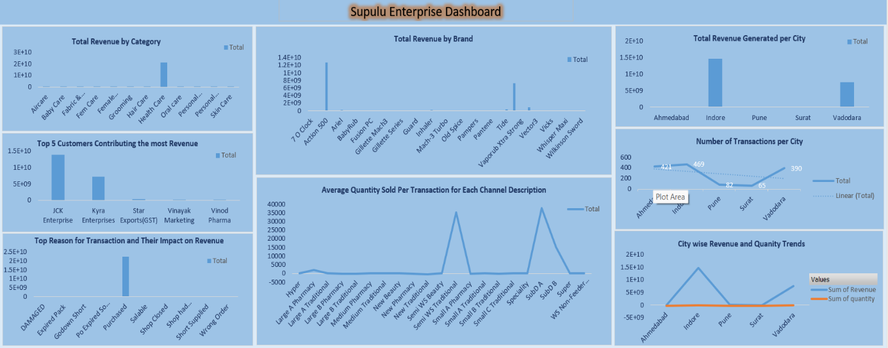

Fig. Screenshot of Supulu Enterprise Dashboard

**Findings**:

1. Health Care is top category by total revenue.
2. Action 500 is the top Brand by total revenue.
3. JCK Enterprise, Kyra Enterprises, Star Exports (GST), Vinayak Marketing,

Vinod Pharma are the top 5 customers contributing the most revenue.

1. Most frequently sold product purchased by Maximus Jun22 (New Traditional) 60.
2. Indore is top city who generates maximum revenue.
3. Indore is top city by maximum number of transactions.
4. SubD A is top channel description by maximum average quantity sold per transaction.
5. Purchased is top reason for transaction for gaining maximum revenue.
6. Indore is top city by maximum revenue and maximum quantity.